**Orientation Challenge: Digital Twin Research**



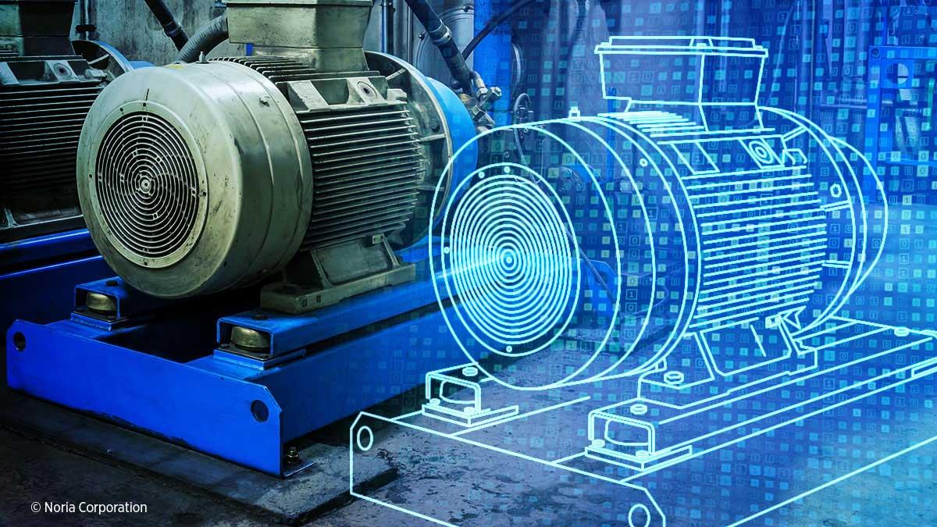

*By: Johnson Domacasse (#4471709)*

*26 February 2024*

# Abstract:

A digital twin is a digital representation of a product, person, process and more that makes use of data to simulate a real time situations and their outcomes. Digital twins technology is becoming increasingly popular because of the field machines and devices producing more data. Using the digital twin, we can make use of this data.

Contents

Abstract: 1

1. Introduction: 3

2. Available tools: 3

2.1 Microsoft Azure Digital Twin: 3

2.2 Siemens Digital Enterprise: 4

3. preferred program: 4

4. alternate interactions: 5

5. Conclusion 5

6. Bibliography 5

# Introduction:

“A digital twin is a digital representation of a physical object, person, or process, contextualized in a digital version of its environment. Digital twins can help an organization simulate real situations and their outcomes, ultimately allowing it to make better decisions.” In more simple terms, one can have a 3D-model of what can be a house up to a factory. This model can be used to simulate the behaviour of this environment to see how this functions in real life. This is one of the many types of digital twins that currently exist**[1].**

The purpose of this report is to dig a bit deeper into the tools that are available, experiment with them and finally document the findings within this report.

# Available tools:

This section highlights two of the many available digital twin tools.

## Microsoft Azure Digital Twin:

Azure digital twins is a platform as a service (PaaS) offering that enables the creation of twin graphs based on digital models of entire environment, which can be buildings, factories, farms energy networks and many more. Azure Digital Twins can be used to design a digital twin architecture that represents actual IoT devices in a wider cloud solution, and which connects to IoT hub device twins to send and receive live data. **[2]**

By taking advantage of the expertise the users already possess with digital twin, using Azure digital twins, the user is able to solve problems such as the following and more:

* Model any environment, bringing digital twins to life in a scalable and secure manner. See figure 1.
* Connect assets such as IoT devices and existing business systems, using a robust event system to build dynamic business logic and data processing.
* Building models of your environment that also displays business logic and twin data in context.

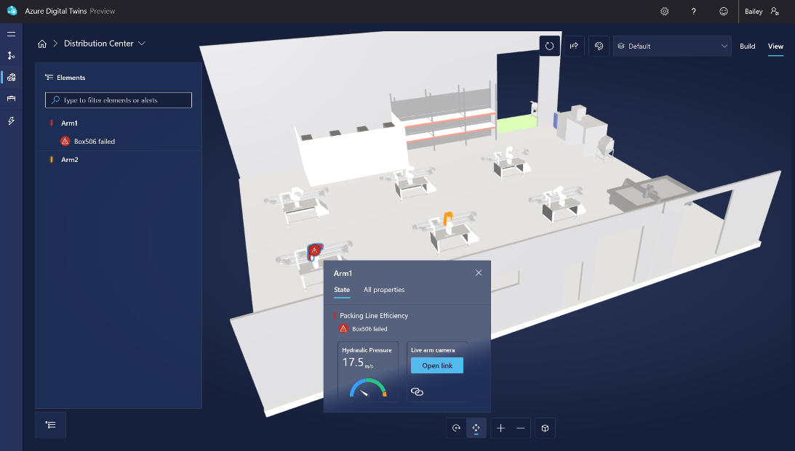

**Figure 1:** Azure digital twin preview window.

## Siemens Digital Enterprise:

The software combines both the digital and real world to collect, understand and use the industrial IoT data meaningfully. These industries go from standard enterprises to digital ones. The industrial world is facing rapidly changing challenges. These include geopolitical tensions, technological changes shifts in global markets and more. To combat these challenges, digitalization and automation are implemented within these industries. The digital twin software is used to perform scenarios that can occur within the industry. The value gained from predicting the future performance with these scenarios is tremendous**[4].**

Figure 2 shows the software that both Siemens and Bentley have developed a software called PlantSight. It is a solution that uses as-operated and up-to-date digital twins to synchronize physical reality and engineering data in order to create a holistic digital context for operating plants**[5].**

**Figure 2:** PlantSight software.

# preferred program:

*Note:* *due to the fact that Fontys doesn’t have the necessary technology for testing/prototyping, I will provide a show an example of a digital twin being used in a YouTube video. The things written in this section are based on the research conducted and my own opinion.*

The preferred program to prototype with digital twins is azure digital twins. This decision was based on two factors. The first being the documentation available that involves digital twin is far more in depth than that of the other. Using the documentation, I was able to find enough information on what a digital twin is. The documentation almost feels like it holds your hand as you are going through the it. It offers guide, tutorials and concepts for one to play around with to learn about the technology. This makes this program a bit more user friendly. While the offer may offer more tools for the experienced engineers within that department.

The second is the price. I was not able to find anything around pricing for Siemens. They require one to contact them personal for price quotes and additional information. For Azure, it is the same concept where you request a quote however, they offer a calculator that gives you an idea on how much it would cost based on the messages, operations and query units.

# alternate interactions:

One of the interesting interactions that can be used with digital twins is leisure. The technology can be used to create immersive experiences for customers. For example, take amusement parks that can offer a taste of the ride virtually before the customer actually visits the theme park. This allows customers to plan their visit and prioritize attractions they want to experience which can lead to a more satisfying experience**[5].**

# Conclusion

Most, if not all, field devices and control units operating in one floor can produce a lot of data. Data is very important in industry 4.0. Now that we are close to industry 5.0, data is now more important than ever. With the digital twin technology, we are one step closer to making efficient use of not just the data but also the time that is being saved.

# Bibliography

**[1]** - McKinsey & Company. (2023, July 12). *What is digital-twin technology?*. McKinsey & Company. <https://www.mckinsey.com/featured-insights/mckinsey-explainers/what-is-digital-twin-technology>

**[2] -** Baanders. (n.d.). *Azure Digital Twins Documentation - tutorials, API reference*. Tutorials, API Reference | Microsoft Learn. <https://learn.microsoft.com/en-us/azure/digital-twins/>

**[3] -** *Digital enterprise*. siemens.com Global Website. (n.d.). <https://www.siemens.com/global/en/products/automation/topic-areas/digital-enterprise.html>

**[4] -** *Siemens and Bentley Systems Release Digital Twin Software plantsight*. Manufacturing AUTOMATION. (2019, September 27). <https://www.automationmag.com/8752-siemens-and-bentley-systems-release-digital-twin-software-plantsight/>

**[5] -** Roller, J. (2023, August 1). *5 digital twin use cases*. IEEE Computer Society. <https://www.computer.org/publications/tech-news/trends/digital-twin-use-cases>

**[6] -** YouTube. (2020, September 16). *I built a digital twin of my home in Lockdown - Emerging Technology*. YouTube. <https://www.youtube.com/watch?v=nwFed03fS_s&t=113s>